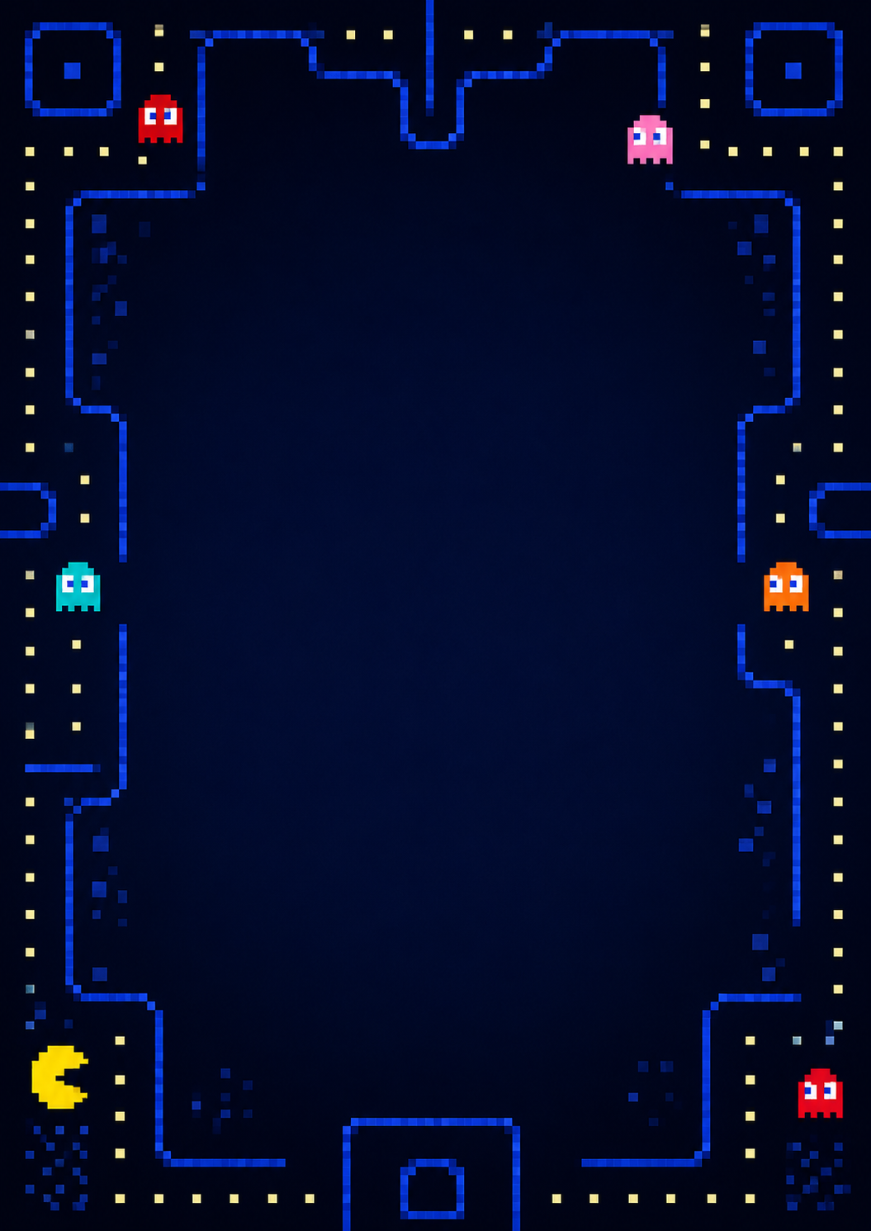

1 | 2 | 2 | 3 | 4 | 2 | 1
4 | 2 | 3 | 3 | 2 | 2 | 4
2 | 3 | 2 | 3 | 4 | 1 | 2
3 | 2 | 1 | 3 | 1 | 1 | 2
4 | 1 | 1 | 3 | 2 | 4 | 4
2 | 2 | 4 | 3 | 4 | 2 | 1
1 | 4 | 1 | 3 | 1 | 2 | 2


3 | 3 | 3 | 3 | 2 | 4 | 4
3 | 1 | 4 | 2 | 1 | 3 | 3
1 | 1 | 2 | 1 | 3 | 1 | 1
1 | 2 | 2 | 2 | 4 | 4 | 3
1 | 2 | 3 | 3 | 2 | 3 | 1
3 | 2 | 4 | 4 | 2 | 4 | 1
4 | 4 | 2 | 2 | 3 | 1 | 1

1 | 1 | 1 | 4 | 4 | 3 | 1
3 | 1 | 4 | 3 | 2 | 4 | 1
3 | 1 | 3 | 3 | 2 | 4 | 2
3 | 1 | 1 | 1 | 4 | 3 | 2
3 | 1 | 2 | 4 | 1 | 3 | 2
2 | 2 | 4 | 2 | 1 | 3 | 1
2 | 4 | 4 | 4 | 4 | 4 | 3

